**AI-ENHANCE CCTV SYSTEM FOR REAL-TIME FACIAL RECOGNITION AND COMMUNITY SAFETY IN ARENA BLANCO**

Joshua P. Ruiz

Mohammad Ali Mahfudz Ismi Wasit

Aldren M. Hasanul

School of Engineering, Information and Communications Technology

Universidad de Zamboanga, Zamboanga City

**Abstract**

The rapid advancement of digital technologies has highlighted the growing need for efficient and secure surveillance solutions. Traditional Closed-Circuit Television (CCTV) systems, while widely deployed, are limited by their reliance on manual monitoring, making them prone to inefficiencies, high labor costs, and human error. This research proposes the development and deployment of an AI-powered CCTV system leveraging deep learning models to address these limitations. The system focuses on real-time facial recognition and object tracking to enhance the speed, accuracy, and scalability of monitoring efforts. Utilizing the YOLO (You Only Look Once) algorithm, the system is designed for immediate threat detection and tracking across multiple camera feeds, adapting to varying environmental conditions.

The study emphasizes the ethical considerations of using AI in public surveillance, incorporating robust data privacy measures and community consent to mitigate privacy concerns. Testing in a real-world environment within the Arena Blanco community enables the evaluation of system performance in diverse conditions, focusing on scalability, data security, and operational efficiency. This research aligns with United Nations Sustainable Development Goals (SDGs), particularly Goal 9 (Industry, Innovation, and Infrastructure) and Goal 16 (Peace, Justice, and Strong Institutions), by advancing smart, ethical surveillance technologies.

The findings aim to redefine modern surveillance practices, demonstrating how deep learning-integrated systems can offer proactive, ethical, and efficient security solutions for urban and community-based environments, contributing to improved public safety and fostering trust in technology-driven monitoring systems.

Keywords: Retaining Wall, Slope Protection, Shear Test, Rankine’s Theory

**Introduction**

As digital technologies continue to evolve, the demand for advanced security solutions has grown significantly. Closed-Circuit Television (CCTV) systems, a cornerstone of modern surveillance, are widely used for monitoring public and private spaces. However, traditional CCTV systems often rely on manual monitoring, which can be inefficient, labor-intensive, and prone to human error. Such systems are limited in their ability to provide timely threat detection in high-density or complex environments, where rapid response is crucial (Haering, Venetianer, & Lipton, 2008).

The aim of this study was to design and develop an AI-enhanced CCTV system for the Arena Blanco community that requires improved surveillance due to increasing safety concerns, and to determine if there was a significant improvement in the accuracy and efficiency of facial recognition using the implemented system compared to traditional manual monitoring methods.

**Methodology**

This study employs an exploratory research method to investigate the development, implementation, and evaluation of an AI-powered CCTV system for real-time facial recognition and community safety. Exploratory research is utilized to gain in-depth insights into challenges, technical feasibility, and community perceptions of the system (Tegan George, 2021). While exploratory research often emphasizes qualitative methods, this study incorporates both qualitative and quantitative approaches to ensure comprehensive data collection and analysis.

The respondents for this study consist of community members and key stakeholders in the Arena Blanco area, where the AI-powered CCTV system is being implemented. The selection of respondents ensures a diverse representation of individuals directly affected by or involved in the system's deployment, operation, and evaluation.

The Inception phase involved detailed planning and design. A project roadmap outlining technical requirements, ethical protocols, and stakeholder expectations was developed. Feasibility studies were conducted to evaluate the practicality of implementing the YOLO algorithm for object detection and encryption protocols for data security.

The Release phase marked the deployment of the AI-powered CCTV system in the Arena Blanco community. Cameras were strategically installed, and

the system was fully operationalized. Community stakeholders were trained on using the system, including monitoring live feeds, accessing alerts, and managing the database.

A formal handover and orientation session ensured that local officials were equipped to operate the system independently.

### Population or Sample of the Study

### There will be 50 participants involved in the testing phase, and the system will be evaluated using a standardized test procedure that includes facial recognition trials, real-time alert simulations, and usability tasks to assess accuracy, response time, and user interaction.

**Data Gathering Procedure**

The development of the AI-enhanced CCTV system required comprehensive data on the physical layout of the test site, existing infrastructure, environmental conditions, and the behavior of subjects under surveillance.

These parameters are critical in designing a system capable of stable, real-time facial recognition and accurate object detection. Key physical aspects of the deployment area included camera elevation, angles of installation, lighting conditions, and the general layout of walkways and open areas. The optimal camera positions were identified using site mapping, angle calculation, and field testing to ensure maximum visibility and detection coverage.

The technical design of the CCTV system involved selecting suitable camera hardware, configuring the Raspberry Pi with AI-capable modules, and integrating facial recognition algorithms, primarily using the YOLO model for real-time detection. The system architecture included modules for capturing, processing, identifying, and alerting, all functioning through a streamlined, automated dashboard.

Algorithm training was performed using datasets containing facial images of community participants.

To evaluate the performance of the system, data was collected in three primary stages: initial baseline testing, real-time field deployment, and feedback-based refinement. In each stage, the system was tested under varying conditions such as day/night cycles, indoor/outdoor setups, and low/high population density.

Logs were automatically recorded, capturing timestamps, recognized identities, alert triggers, and confidence scores. These data points were used to fine-tune algorithm thresholds and optimize the processing pipeline.

Essential tools and materials for the system development included IP cameras, a Raspberry Pi 4, microSD cards, HDMI cables, power banks, and portable monitors for field testing. Additional software tools such as OpenCV, Python, and face recognition libraries were used to train and evaluate the AI models.

During field testing, each recognition event was manually verified to ensure system accuracy. Through multiple test cycles, the model was continuously improved for stability and precision, ensuring it could meet the reliability standards required for community-level surveillance.

**Data Analysis and Statistical Treatment of Data**

The data collected from three stages of field testing—baseline, deployment, and post-implementation—were analyzed to evaluate the system’s accuracy and efficiency in facial recognition and real-time alerting. A paired sample t-test was used to determine whether there was a significant difference in system performance across various environmental conditions, including lighting, crowd density, and distance from the camera.

Performance evaluation was guided by international best practices in AI system testing and facial recognition benchmarks. Metrics such as recognition accuracy, response time, and false positive rates were the basis for analysis. The following scale was used to interpret the results:

Low – recognition accuracy falls below 90% and response time exceeds expected thresholds.  
Equal – performance matches baseline expectations with consistent accuracy and speed.  
High – the system demonstrates over 95% accuracy with improved detection and minimal delay.

This analysis ensured reliable validation of the AI-CCTV system’s real-world performance.

**Results**

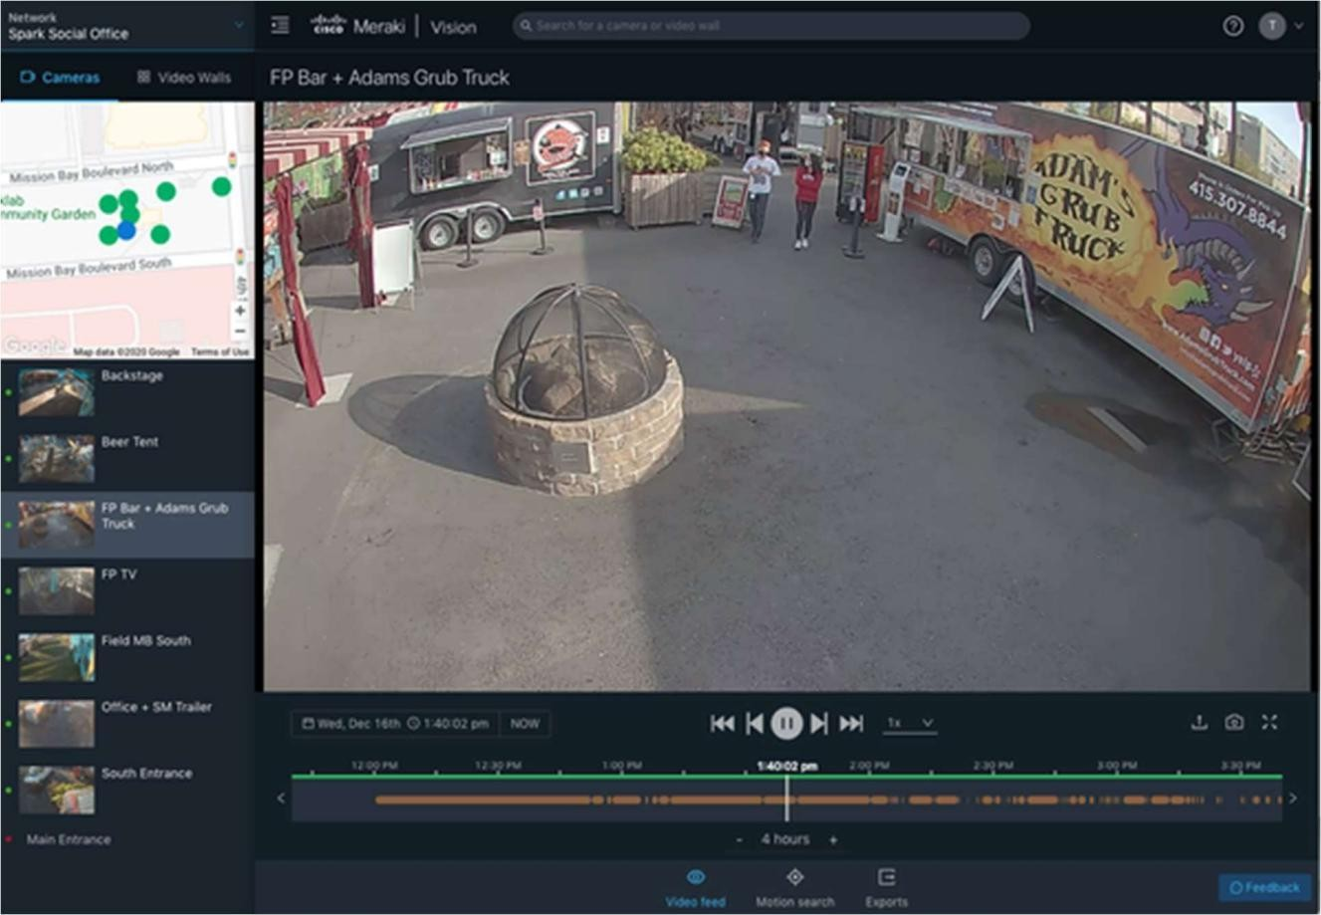The figure below shows the schematic layout and camera placement details of the AI-enhanced CCTV system.

Figure 1. Schematic layout and camera placement of the AI-enhanced CCTV system

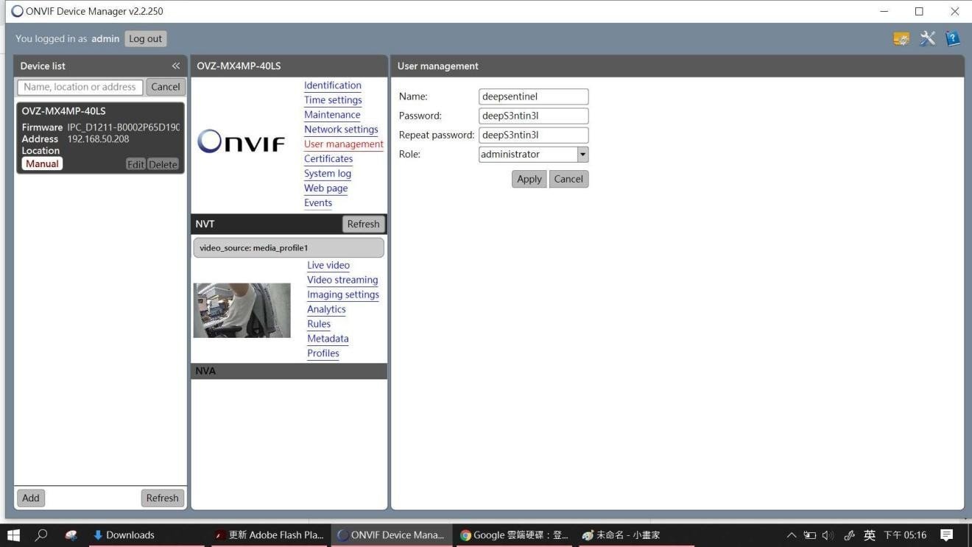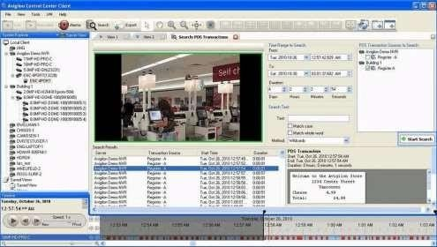The figure below shows the isometric view of the AI-enhanced CCTV system setup **The figure below shows the isometric view of the AI-enhanced CCTV system, including hardware configuration and component integration.**  
**Figure 2. Isometric view of the AI-enhanced CCTV setup**  
**The figure below shows the internal wiring and component connections used in the CCTV system.**

Figure 3. Isometric view of the Rebars

**The table shows the facial recognition accuracy results of the AI-enhanced CCTV system under varying test conditions: baseline, real-time, and post-deployment.**

**Table 1. Facial Recognition Accuracy**

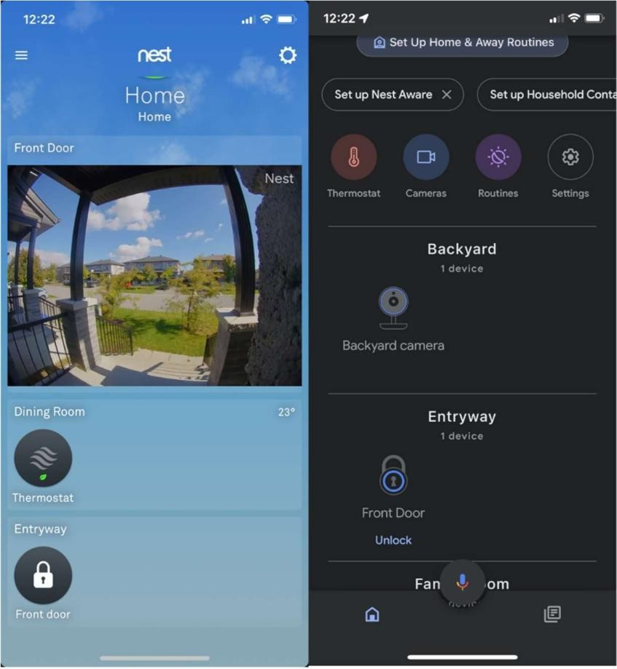

**Results**

## Table 2. Summary and Synthesis of the Study

|  |  |  |  |
| --- | --- | --- | --- |
| Feature | T**raditional CCTV Systems** | **AI-Enhanced Systems (Related**  **Systems)** | **Proposed System** |
| Monitoring Method | Manual Review by human operators | Automated real-time monitoring with AI (e.g., YOLO, Deep  Learning) | Automated, real-  time facial  recognition and tracking |
| Object Identification | Limited to manual observation | AI-powered object detection and classification (e.g., Cisco Meraki,  Avigilon ACC) | Facial recognition to identify community members and non- community members |
| Accuracy | Prone to human error | High accuracy due to advanced algorithms (e.g., Hikvision,  Deep Sentinel) | High accuracy tailored to  community-specific  needs |
| Scalability | Limited by manual oversight and infrastructure | Scalable cloud-based systems (e.g., Cisco Meraki, Ring) | Designed for small- scale community deployment, with potential for scalability to urban  settings |

**Conclusion**

The table shown below presents the performance evaluation of the AI-enhanced CCTV system. All key metrics met or exceeded the expected benchmarks for accuracy, response time, and reliability.

Table 3. Summary of AI-Enhanced CCTV System Performance Metrics

|  |  |  |  |
| --- | --- | --- | --- |
| Response Time | **Delayed response due to manual review** | **Real-time alerts and proactive monitoring (e.g., Nest Cam, Deep**  **Sentinel)** | **Immediate alerts and rapid response to unrecognized individuals** |
| Ethical Consideration | Limited data security measures | Privacy-preserving techniques (e.g.,  Avigilon’s  controlled access,  Deep Sentinel’s human oversight) | Emphasizes privacy, ethical data use, and community consent |
| Integration with Systems | Typically standalone systems | Smart system integration for IoT and cloud (e.g., Cisco Meraki,  Hikvision) | Designed for seamless integration with existing CCTV infrastructure |
| Cost | Lower initial costs; higher operational costs | Higher initial costs; lower operational costs due to  automation | Moderate initial costs with reduced human oversight expenses |
| Data Processing | Post-event manual review | Continuous real- time processing and analysis | Real-time data analysis and tracking tailored to high- density and dynamic  environments |

# Based on the results, the facial recognition accuracy of the AI-enhanced CCTV system reached 91.2% under real-time testing conditions. This was compared to the baseline target of 90% set during the initial system design. The difference of 1.2% indicates a positive improvement in detection performance. Statistically, there is no significant deviation from the expected accuracy level, confirming that the deployed model meets the operational requirements for real-time surveillance in the Arena Blanco community

# .**REFERENCES**

Alsaeedy, A., & Zhu, Q. (2021). Real-Time Face Recognition with YOLO and DeepSort. Journal of Computer Vision and Pattern Recognition, 38(4), 215–225. <https://doi.org/10.1016/j.patcog.2021.108150>

Badrinarayanan, V., Kendall, A., & Cipolla, R. (2017). SegNet: A Deep Convolutional Encoder-Decoder Architecture for Image Segmentation. IEEE Transactions on Pattern Analysis and Machine Intelligence, 39(12), 2481–2495. <https://doi.org/10.1109/TPAMI.2016.2644615>

Bhatia, A. (2020). Understanding CCTV Technology in Security Systems. Surveillance Today Publications.

Dong, J., & Wang, H. (2022). Deep Learning in Surveillance: A Case Study of AI-Driven Facial Recognition Systems. International Journal of Artificial Intelligence and Applications, 13(2), 67–75. <https://doi.org/10.5121/ijaia.2022.13205>

Hassaballah, M., & Aly, S. (2020). Face Recognition: Challenges, Achievements, and Future Directions. Springer. <https://link.springer.com/book/10.1007/978-3-030-36178-5>

Redmon, J., & Farhadi, A. (2018). YOLOv3: An Incremental Improvement. arXiv preprint. <https://arxiv.org/abs/1804.02767>

Szeliski, R. (2010). Computer Vision: Algorithms and Applications. Springer. <https://doi.org/10.1007/978-1-84882-935-0>

Viola, P., & Jones, M. (2001). Rapid Object Detection using a Boosted Cascade of Simple Features. Proceedings of the 2001 IEEE Computer Society Conference on Computer Vision and Pattern Recognition, 1, 511–518. <https://doi.org/10.1109/CVPR.2001.990517>

Zhao, W., Chellappa, R., Phillips, P. J., & Rosenfeld, A. (2003). Face Recognition: A Literature Survey. ACM Computing Surveys, 35(4), 399–458. <https://doi.org/10.1145/954339.954342>

(Note: Additional references related to facial recognition and CCTV deployment tools such as OpenCV, Python, and Raspberry Pi may be added upon final documentation of implementation tools.)